**Mautic Social Login Guide**

With Mautic's **Social Login**, users can easily sign in via their favorite social platforms like Twitter, Facebook, or LinkedIn. The social login feature automatically pre-fills forms with profile data and updates or creates new contacts in Mautic, streamlining the user experience.

**Before You Begin: Setup Requirements**

Before enabling social login, make sure you have created social media apps on the platforms you want to integrate:

* [X-Developer](https://developer.twitter.com/en/account/)
* [Facebook](https://developers.facebook.com/products/facebook-login/)
* [LinkedIn](https://www.bing.com/ck/a?!&&p=b2b85466e898e3f3JmltdHM9MTcyODQzMjAwMCZpZ3VpZD0wZmNhOGE5ZC05ODA0LTY0OGYtMjVhYy05ZWQwOTk2MzY1NjYmaW5zaWQ9NTE5Mg&ptn=3&ver=2&hsh=3&fclid=0fca8a9d-9804-648f-25ac-9ed099636566&psq=linkedin+developer+app&u=a1aHR0cHM6Ly9kZXZlbG9wZXIubGlua2VkaW4uY29tLw&ntb=1)

Once these apps are set up, you're ready to connect them to Mautic!

**Step 1: Authorizing Social Media Plugins**

Before you can use social login, each social media plugin needs authorization. Here’s how to do it:

To get started with social login, you’ll first need to authorize each plugin:

1. **Copy the Callback URL**:

After creating your social app, the platform will ask for a **Callback URL**.

* + Go to Mautic's plugin configuration window and copy the **Callback URL** provided there.
  + Paste it into the appropriate field in your social app setup.

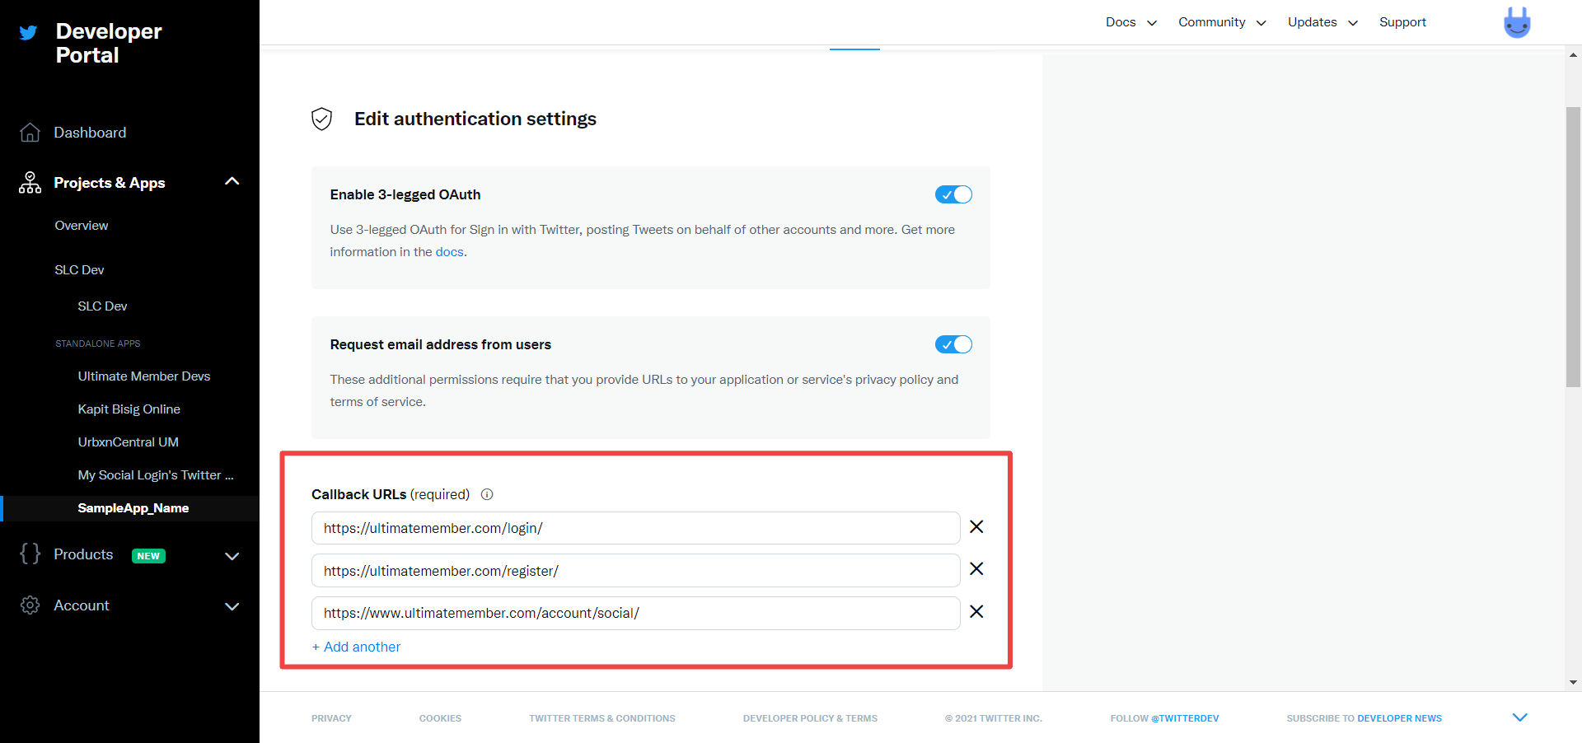



1. **Add Your API Keys**:  
   Now that your social app is set up:
   * Copy the **API Key (Client Key)** and **API Secret (Client Secret)** from the social platform.
   * Paste these keys into the relevant fields in the Mautic plugin configuration.

1. **Authorize the Plugin**:
   * In the Mautic plugin configuration, click **Authorize**.
   * Ensure the plugin is marked as **Published** by toggling the option to “Yes”.
   * Save your configuration to complete the setup.

*Example Image: Mautic plugin configuration screen showing authorized status.*

**Tip**: You can manage each social network under its respective tab in Mautic’s plugin settings. Make sure each network is fully authorized by adding the required API credentials.

**Step 2: Adding Social Login Buttons to Forms**

Once your plugins are authorized, you can add social login buttons to your Mautic forms.

1. **Create or Edit a Form**:  
   Go to the **Forms** section in Mautic and either create a new form or edit an existing one.
2. **Add the Social Login Field**:  
   Select the **Social Login** field from the form builder. Buttons for all authorized social platforms (e.g., Twitter, Facebook, LinkedIn) will automatically appear.
3. **Pre-fill Form Fields**:  
   When users log in using their social accounts, Mautic will attempt to automatically fill in fields like **Name** or **Email** based on their social profile.

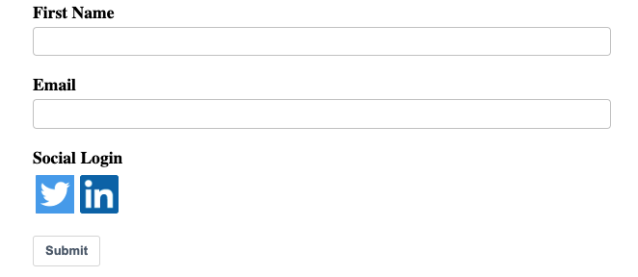

**Note**: Only the buttons for plugins you’ve authorized will work in the form. Ensure all integrations are configured correctly for a smooth user experience.

**Step 3: Configuring Features and Mapping Contact Fields**

Once the plugin is authorized, you can customize how Mautic handles the incoming social profile data.

1. **Map Social Profile Fields to Mautic Fields**:  
   Under the **Contact Field Mapping** tab in the plugin settings, map the fields from the user’s social profile (e.g., Email, Name) to the appropriate Mautic contact fields.
   * You only need to map fields that are relevant to your form.
   * Unmapped fields will not be used to update or create contacts in Mautic.

*Example: Map "First Name" from Facebook to "First Name" in Mautic's contact fields.*

**Supported Social Profile Fields**

Each platform provides different user data fields. Here's a quick reference of the fields you can map:

**Twitter**

* Profile Handle, Name, Location, Description, URL, Time Zone, Language, Email.

**Facebook**

* First Name, Last Name, Name, Gender, Locale, Email, Profile Link.

**LinkedIn**

* First Name, Last Name, Maiden Name, Formatted Name, Headline, Location, Summary, Specialties, Positions, Public Profile URL, Email Address.